SOLE Resources

Science
http://kids.nationalgeographic.com/
http://kids.discovery.com/
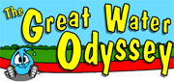http://thegreatwaterodyssey.com/
http://www.strangematterexhibit.com/index.html
http://www.kidsplanet.org/
http://www.harcourtschool.com/activity/exploring_ecosystems/index.html
http://www.wonderville.ca/
vhttp://www.spiderroom.info/index.html
http://www.nwf.org/kidzone/kzPage.cfm?siteId=3
http://www.scholastic.com/magicschoolbus/home_2.htm

Social Studies
http://www.ushistory.org/index.html
http://www.nationalgeographic.com/kids/
http://bensguide.gpo.gov/index.html
http://www.flsenate.gov/senatekids/
http://www.mccollam.com/fun/geoquiz/
http://search.eb.com/blackhistory/

Kid Friendly Search Engines
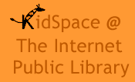http://www.ipl.org/div/kidspace/

http://www.kidrex.org/
http://www.kidsclick.org/

http://www.kidzsearch.com/
http://www.factmonster.com/

Wonderopolis: http://wonderopolis.org/
Brainpop; https://www.brainpop.com/

