Music in the Classroom
Recent research shows that musical experiences in childhood can actually accelerate brain development, particularly in the areas of language acquisition and reading skills. When children learn concepts through songs, they have a 64% better chance of committing those concepts to memory. But academic achievement isn’t the only benefit of music education and exposure. Music ignites all areas of child development and skills for school readiness: intellectual, social and emotional, motor, language, and overall literacy. Music helps the body and the mind work together. Exposing children to music during early development helps them learn the sounds and meanings of words. Dancing to music helps children build motor skills while allowing them to practice self-expression.
I use music in all aspects of the classroom. During all worktime, different types of soft music are always playing. I use classical, jazz, and new age. Music by Jim Brickman and other contemporary piano musicians are used daily.
I use music to teach all concepts in reading, math, science, social development, leadership skills, and language development. For example, I use many songs by Dr. Jean Feldman for reading and math. I don’t stop with just singing the songs, though. I make big books and anchor charts to accompany the songs so children not only sing, but see and hear and touch. The children can then use the big books to sing on their own, reinforcing skills.
Below are some examples of big books which I have made to accompany songs, the skill being reinforced, and the name of the CD used for singing. Most of these songs are now available on iTunes for download.
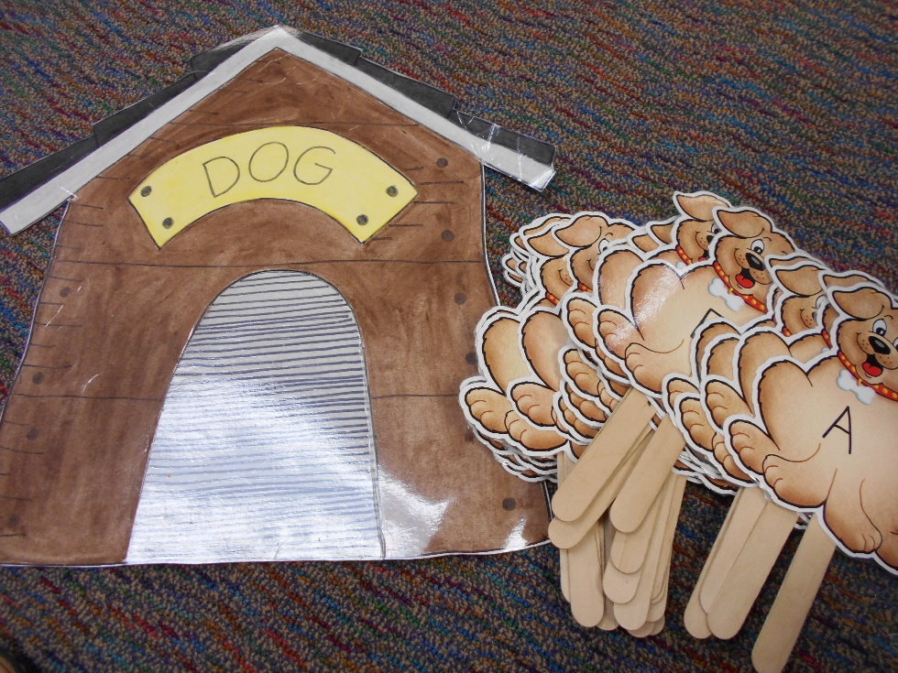
I made this doghouse with a door that opens and I put dogs with letters on sticks. This is used with the song, “Who Let The Letters Out?” by Dr. Jean Feldman. The leader holds the doghouse while the teacher pulls the dogs out of the doghouse as the children sing each letter and sound.
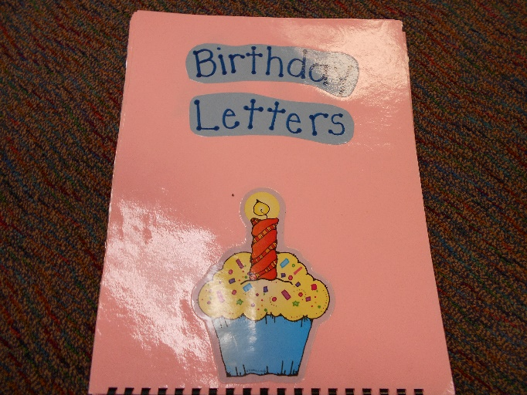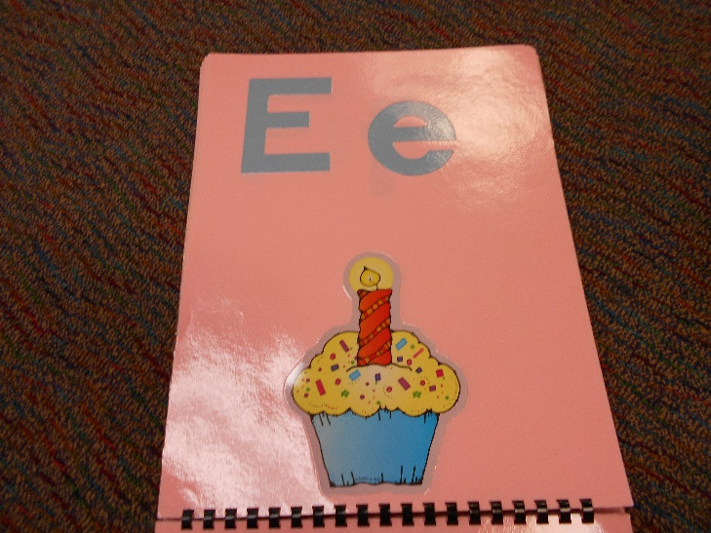
Whenever we have a birthday in kindergarten, we do “Birthday Letters” by Dr. Jean Feldman. The big book reinforces the letters and sounds and is very simply made.
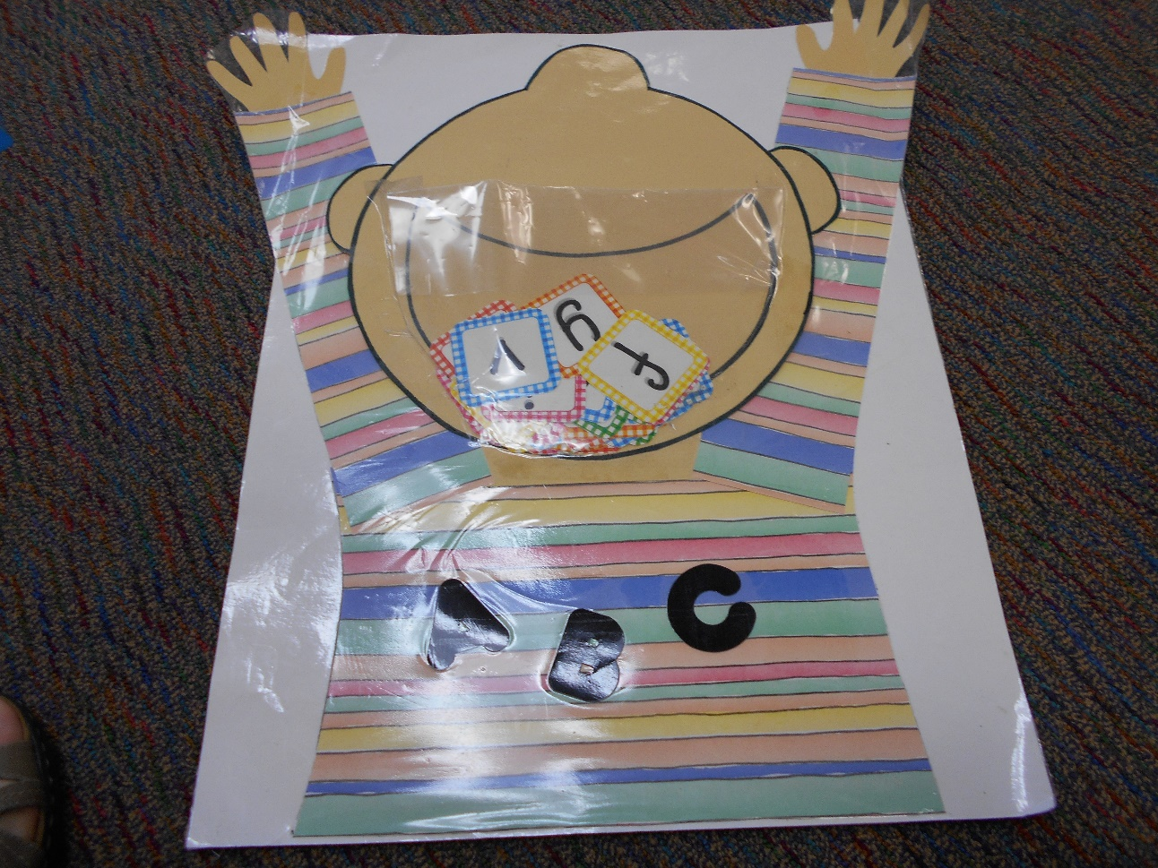
This is another letter song, “I’ve Got The Whole Alphabet In My Mouth” by Dr. Jean. The leader holds the chart while the teacher drops the letters into the mouth. The children review sounds and letters.
We also sing many songs for calendar concepts and math concepts.
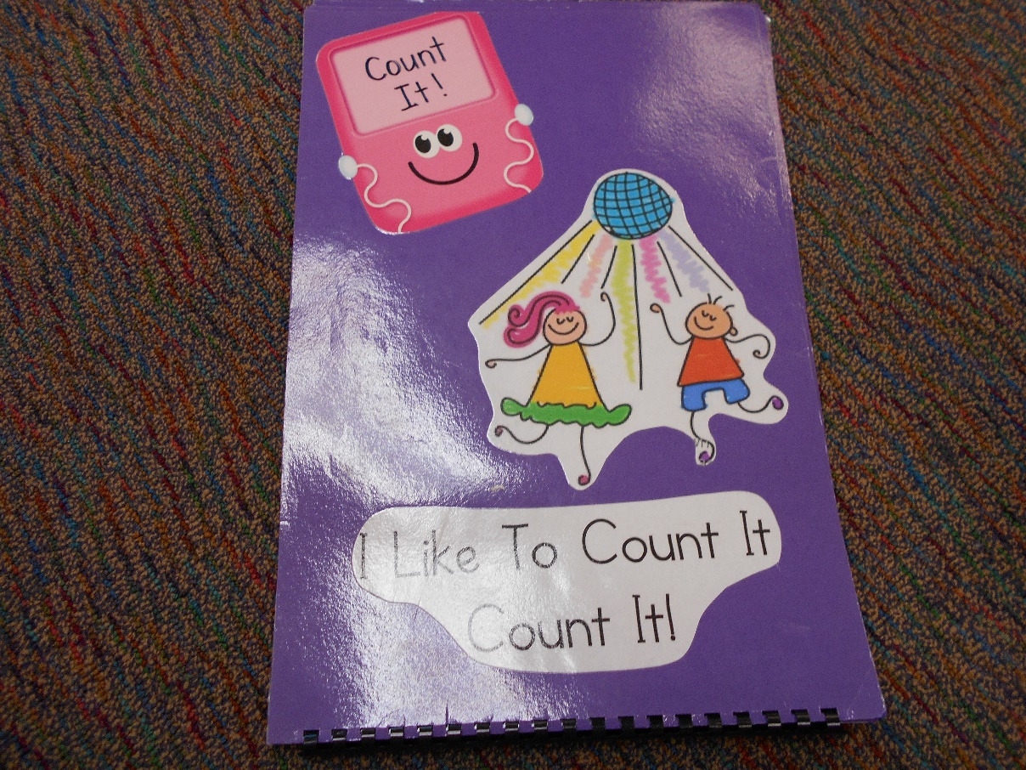
We use this big book to accompany a song for skip counting. This song is called, “I Like to Count It, Count It” by Shari Slone. It covers counting by 1’s, 2’s, 5’s, and 10’s.
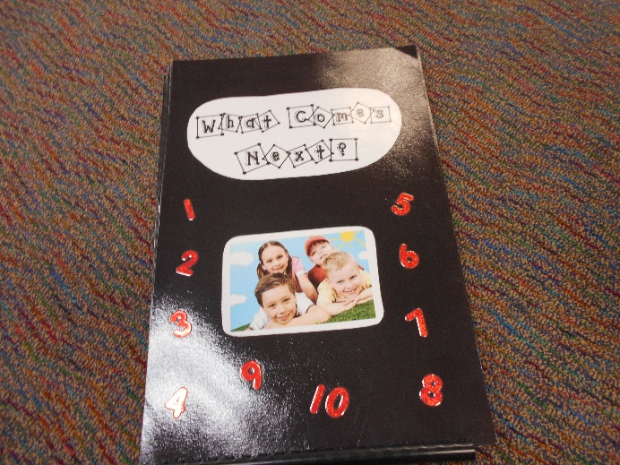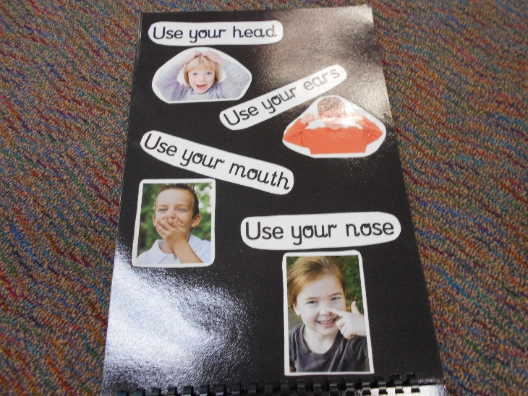
This is a big book to accompany Jack Hartmann’s song “What Comes Next?” This book gives numbers in the song and the children guess what numbers come next.
All these big books are easily made using Google Images. I have many, many, more projects, lesson plans, and music to share. Please contact me!

Websites:
www.heidisongs.com
www.drjean.org
www.jackhartmann.com
www.kidscount1234.com
www.rainbowswithinreach.com

