Project Based Learning
Project Based Learning is a teaching method in which students gain knowledge and skills by working for an extended period of time to investigate and respond to an authentic, engaging and complex question, problem, or challenge. To bring this to a kindergarten level, I use all kinds of different materials, projects, and activities to reinforce learning concepts. I do not use worksheets unless they are part of the project. At no time are kindergartners ever just sitting at their tables doing a worksheet.
Here are some examples of the kinds of activities we do:
We have been working on a unit about Oviparous Animals. We began by reading the book, “Chickens Aren’t The Only Ones,” by Ruth Heller. We talked about many of the animals that come from eggs. We made eggs that the children painted and we discussed the chicken-egg cycle. We used technology to follow the hatching of eggs.
We then extended what we learned to make paper hens and learn about the chicken life cycle. I extended the lesson into math, where we were learning about the number 12. We learned that eggs that aren’t fertilized are sold to us in “dozens”; each student created a dozen (paper) eggs.
We used an art project involving eggs in a nest next, cutting out ways to make 12. This helps the children recognize different ways that they may see 12. We continued with doing investigation of eggs making predictions about how much they weigh and using different size eggs and predicting what could be growing inside. We also used different objects to measure our eggs.
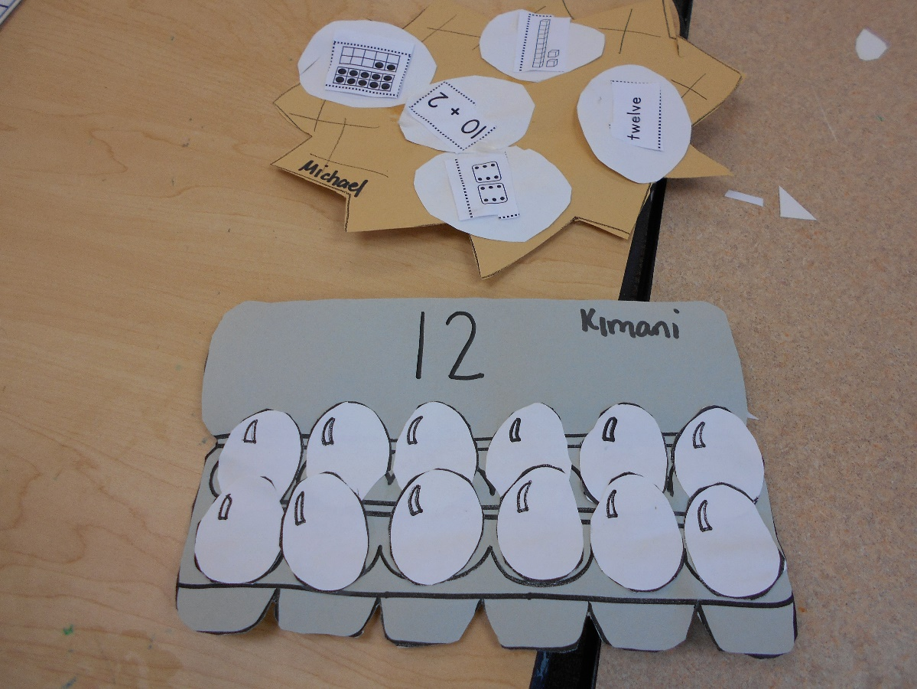
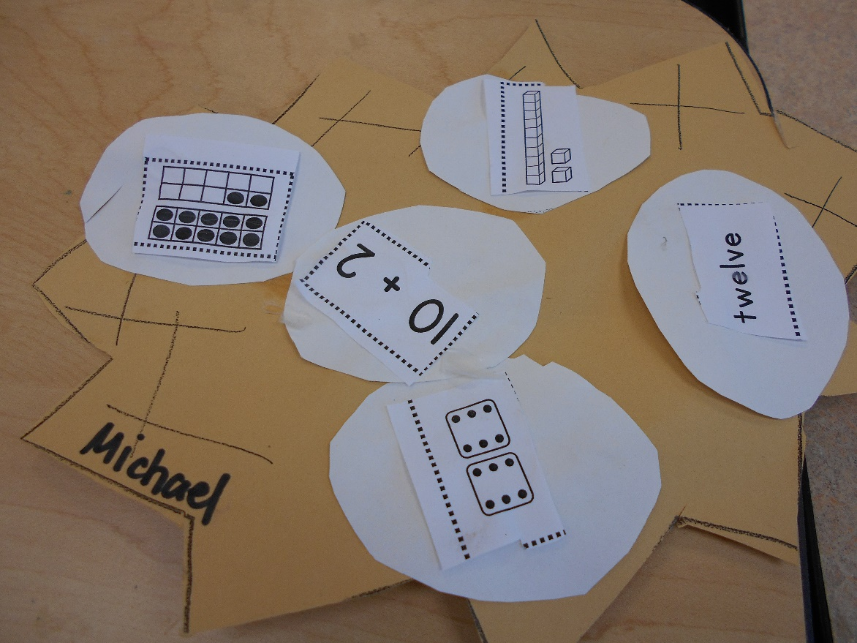

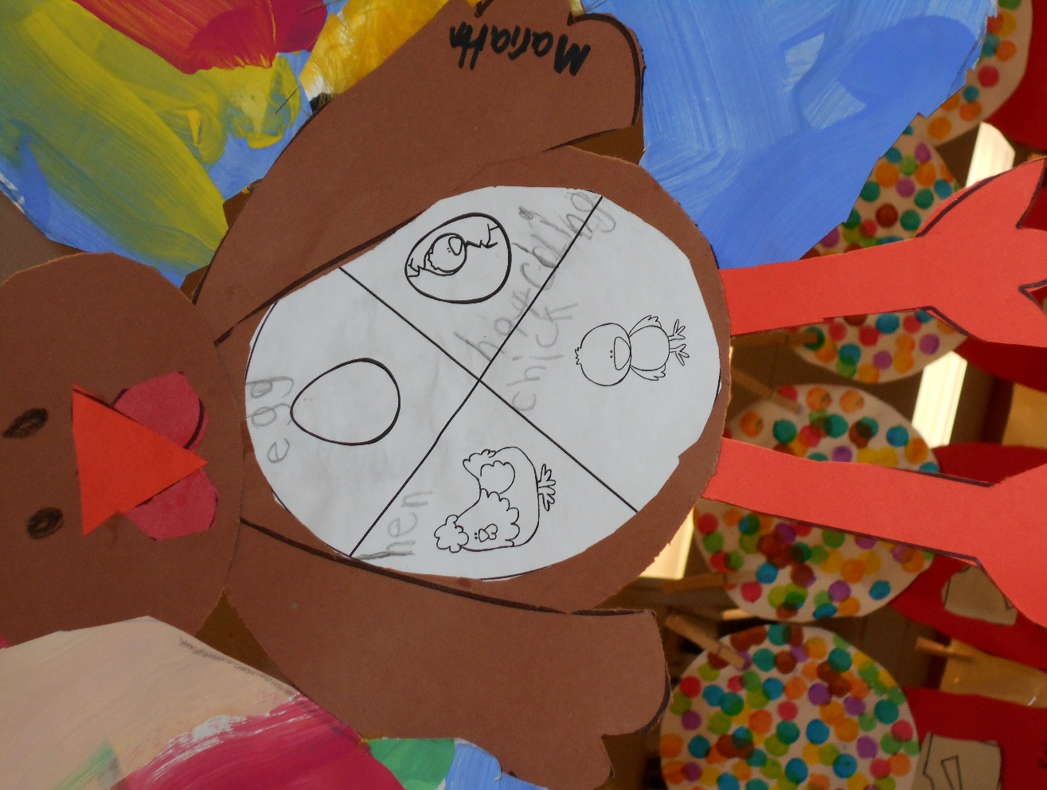
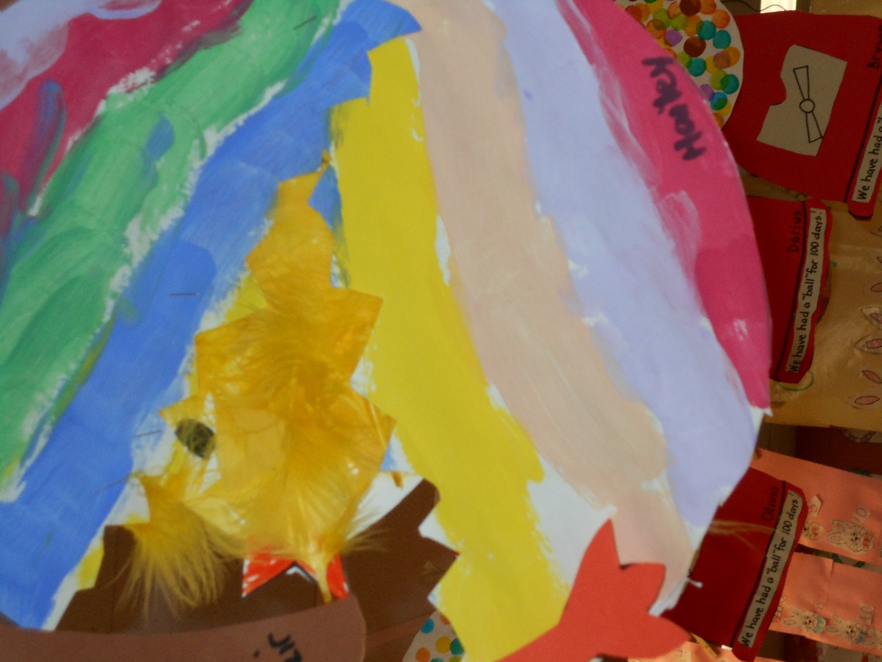

When doing Word Families, which are very important to early reading skills, it is much easier for the children to remember the sounds by “hooking” them to different objects. For example, for the am family, we talk about jam and have toast with jam. Then we make a piece of toast and glue pictures of words with am such as clam, ham, yam, and ram. I make a larger version that hangs up in the classroom and serves as a resource.
