Welcome to Makey Makey!

The Makey Makey is an invention kit that encourages people to find creative ways to interact with their computers by using everyday objects as a replacement for keyboards and mice. With the Makey Makey, you could replace your space key with a banana, use Play-Doh to move and click your mouse, or high-five your best friend to advance PowerPoint slides.

Materials Required
- Makey Makey — The star of the show! The kit should already include:
  - Mini-USB Cable
  - Alligator Clip Cables
  - Tinned Tipped Wires
- A computer with an Available USB Slot
- Button Material (e.g., fruit, Play-Doh, tin foil, copper tape, pencil, a friend)
- Your awesome imagination

Top Side
The Makey Makey is a two-sided circuit board. On the more simple top side, the Makey Makey has six inputs: the up/down/left/right arrow keys, as well as the space bar and mouse left click:
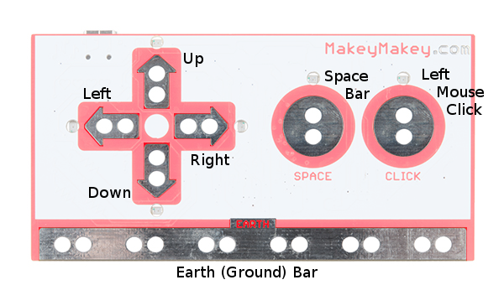

Making Your First Key
To make your “standard” key with the Makey Makey you need the following:
- A connection to a Makey Makey input. This can be done using alligator clips on the hole pairs.
- Connection to a Makey Makey ground (Earth). Again, you’ll connect to earth using alligator clips.
- Some sort of key material. This is the fun/creative part! There’s a world of Makey Makey keys out there. Anything that’s even slightly conductive is just waiting to become a computer input. The classics include your fingers, bananas and pencil scratchings.
- Something to activate the key by connecting between the key material and the ground input. Your fingers work pretty well for this. Anything even slightly conductive will do, though.

Making a Key
Activating a key means creating a closed circuit. For the circuit to work, electrons have to be able to flow from the Makey Makey input key to Makey Makey’s ground. Usually your fingers will be the missing link between those two:

