Name: _________________________
Group: _________________________

Fruit Loops Atomic Model
Using paper plates and Fruit Loops, model an atom of the element you are given and find its atomic symbol, atomic number, atomic mass, number of protons, electrons and neutrons.
- Use your periodic table to find the symbol, atomic number, and atomic mass of your element.
- Calculate the number of protons, neutrons and electrons in your atom. Write this in the blank spots.
  - Trade cards with someone else and check their work! If everything is correct, come get a sticker to put on it before giving it back.
- Glue the atomic information card to the back of your paper plate. Make sure to put your name on it!
- Pick 3 colors of Fruit Loops to represent each particle in #2.
- Using glue, create your atom.
  - The protons and the neutrons live in the nucleus.
  - The electrons live in shells around the nucleus. Each shell can only hold a certain number of electrons, and the shells closest to the nucleus are filled first. The first three shells can hold the following amount each:
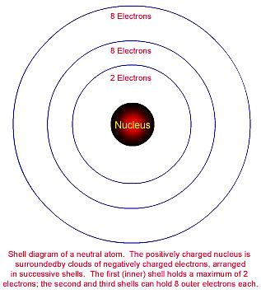

Put your creation on the counter to dry, eat your remaining particles.

