Flying Fish
Exocoetidae
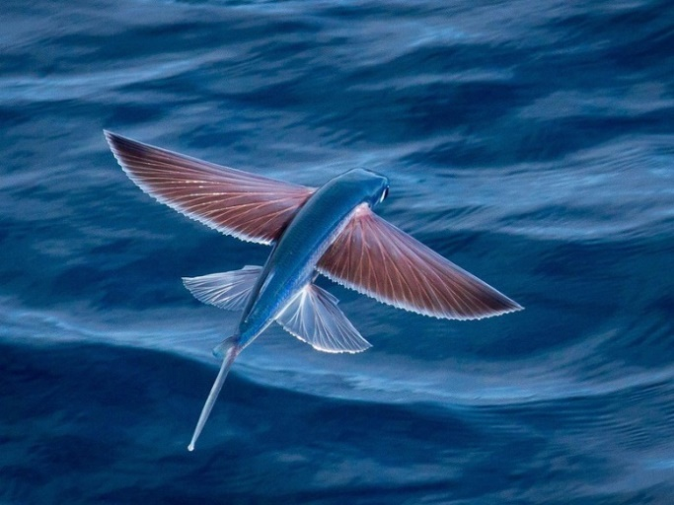
Commonly called flying fish, Exocoetidae are fish known for their ability to jump out of the water and glide long distances using their long, wing-like, pectoral fins. Its torpedo-like body and moving its tail up to 70 times a second allows this fish to generate enough speed to jump out of the water and extend and tilt its pectoral fins to generate lift. The fish then folds its fins to reenter the sea, or drops its tail into the water to push off and prepare for another glide. The average distance these fish go is around 50 meters, but some have been known to take advantage of air currents, allowing them to travel up to 200 meters or more! Flying fish are thought to have developed this adaptation in order to escape predators such as tuna, swordfish, mackeral, and other larger fish.

Wallace’s Flying Frog
Rhacophorus nigropalmatus
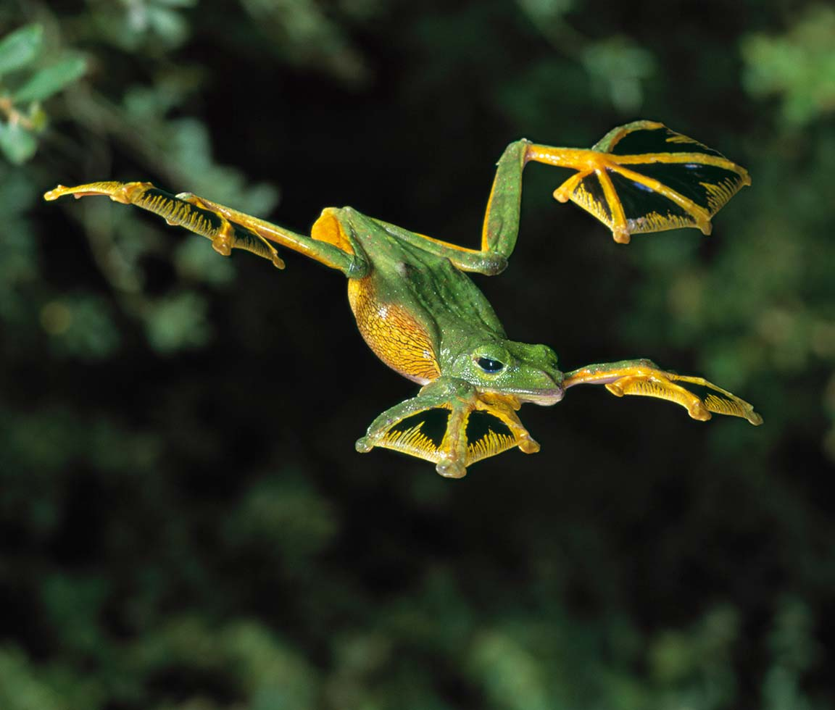
Wallace’s flying frog, also known as the parachuting frog, is a type of Asian frog that lives in the tropical rainforest. Relative to its size, this frog has extremely large feet with fully webbed toes and fingers and oversized toepads. This foot webbing, along with loose flaps of skin on the sides of its body, allow the frog to glide from tree to tree, and use its toe pads to provide a soft landing and stick to trees. Wallace’s flying frog can glide up to 50 feet, and primarily do this to escape from predators.

Flying Squirrel
Glaucomys
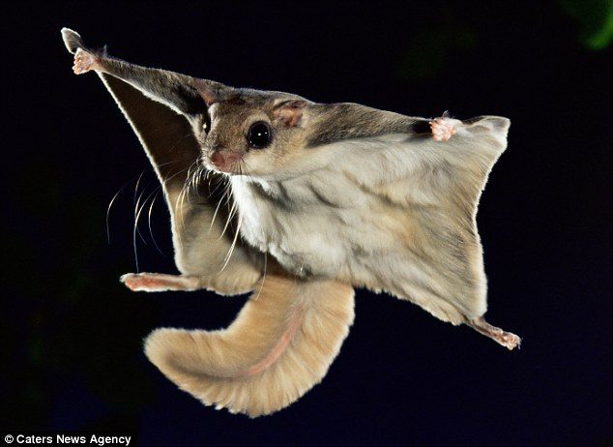
This genus of Flying Squirrel is found in North America. Contrary to its name, these squirrels don’t actually fly, but glide from tree branch to tree branch. The squirrel is able to do this because of a special membrane that attaches from its wrists to its ankles. As it jumps, it extends its limbs to expose the membrane and pick up air pockets that generate lift and allow the squirrel to safely glide, and uses slight movements of the back legs to steer. The squirrel then uses its tail as a brake to slow down as it gets closer to its destination. Flying squirrels can travel large distances this way, covering up to 50 meters! This ability makes them especially good at escaping predators such as owls, hawks, and tree snakes.

Flying Ray
Mobula
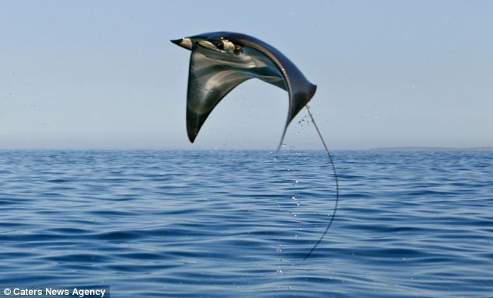
Mobula, or flying rays are rays that spend much of their time jumping out of the sea into the air. Using their long, flat bodies and wing-like pectoral fins, these creatures are easy able to gracefully glide through the water, and jump out at heights up to 2 meters. They are able to stay airborne for several seconds, doing flips and twists, before coming back down and belly-flopping back into the water with a loud clap. Nobody is entirely sure why they do this, but it is thought that it may be some form of communication in order to let other rays know that there is food in the area, and that it is a suitable place to mate and create a nursery ground for offspring

Draco Lizard
Draco volans
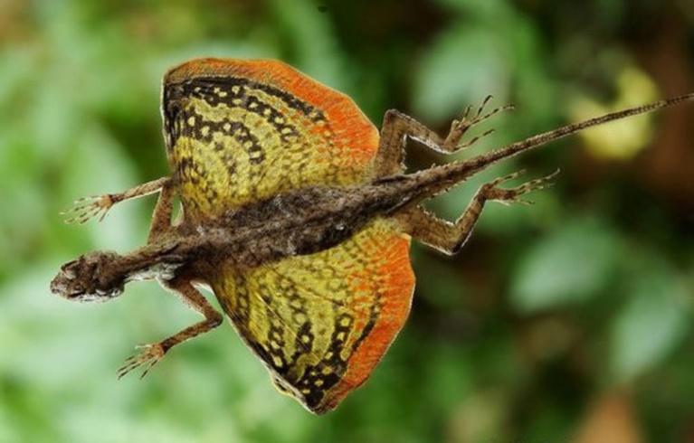
Also known as flying dragons, draco lizards are reptiles that are to glide from tree to tree. The way it is able to do this is with the use of folds of skin that are attached to elongated ribs that they extend to catch air pockets and provide lift, and use their long slender tails to steer. They are known to glide up to 9 meters. This ability is used to escape danger, attract mates, and find food. Because of their very territorial nature, they also use this to chase rival lizards off the trees that they claim as their own.

Wandering Albatross
Diomedea exulans
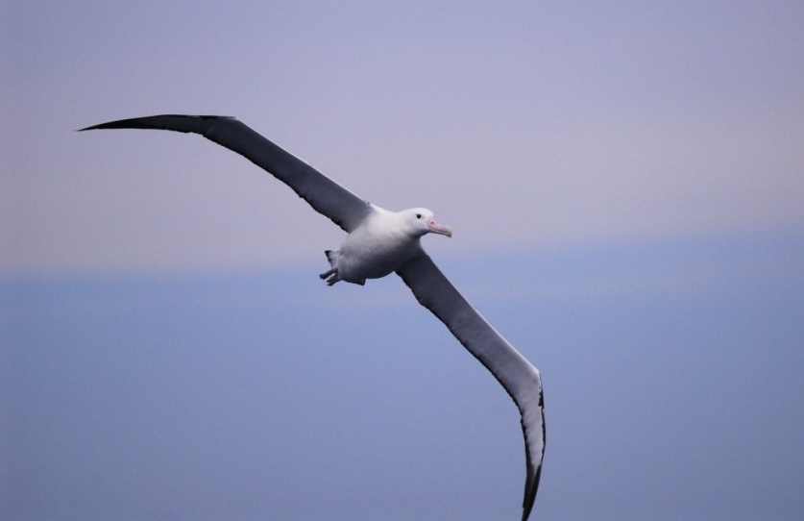
The wandering albatross is thought to be the world’s greatest flying machine. Having the largest wingspan in nature (around 3.5 meters), an albatross will travel up to 16,000 kilometers to deliver one meal to its chick, and can travel hundreds of miles without flapping. They are excellent gliders because of their ability to lock their wings in the open position like switchblades and only need to steer as they ride the wind. Where many seabirds struggle to deal with high intensity wind, an albatross uses it to its advantage by catching the wind and allowing it to soar incredible distances. A 50 year old albatross is expected to have flown at least up to 3.7 million miles, if not more!

Javan Cucumber
Alsomitra
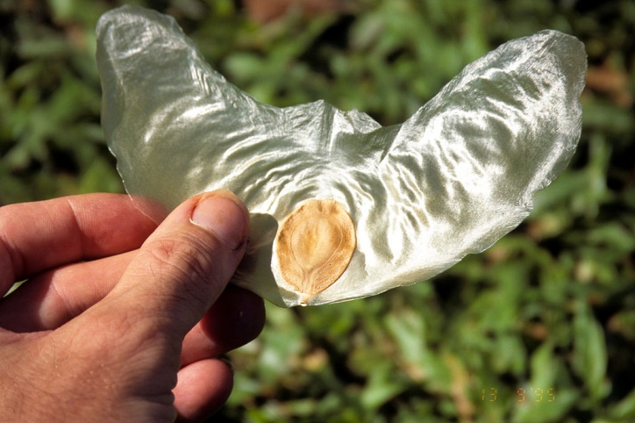
“The Javan cucumber (Alsomitra macrocarpa) is a vine that climbs the trees of tropical forests toward the canopy and sunlight. At great heights it grows pods that contain hundreds of winged seeds called samara. As the wind blows against the opening of the pods, the samara are peeled away and released. Unlike many seeds that make a gliding flight using auto-rotation, the seed of the Javan cucumber vine exhibits a stable gliding flight with its paper-thin wings. The seed’s design is efficient enough to achieve a low descent angle of only 12 degrees and therefore it is able to achieve a slower rate of descent (0.41 meter per second) compared to that of rotating winged seeds (1 meter per second). This aerodynamic advantage allows the seed to be easily carried by the wind.
The construction of the seed and wing gives it this advantage. The seed itself is thin, about 1 millimeter in thickness, and positioned almost exactly at the structure’s center of gravity to give it balance. The wings are even thinner, about a few micrometer to some 10 micrometer. Because the wings are so thin, as the samara is angled up or down, the center of pressure from the wind will shift to reduce that angle. This effect stabilizes the seed and also prevents it from diving. When viewed from above, the wings are angled behind the center of the seed to give it more stability and are slightly tapered toward the tip to make it lighter with less drag. When viewed from the front, the wings are angled upward which helps it fly in a straighter path and prevents spiral instability. The wings also have a sharp leading edge and an aspect ratio (AR=3~4) that results in an appropriate lift-to-drag ratio (L/D= 3~4) to support their gliding flight.” (Source: AskNature.org)
Note: For video footage of the seeds gliding, visit “Vine seeds become 'giant gliders’ '” by the BBC.
Dandelion-
Taraxacum
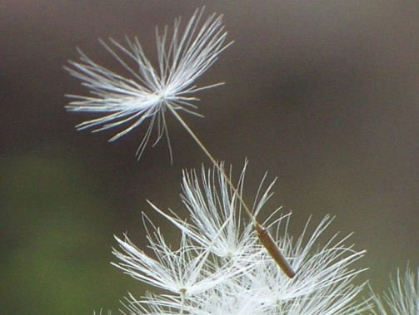
Dandelion seeds are lightweight and have thin filament threads that form a sort of umbrella at the end of each seed stalk. This configuration allows the structure to catch the wind and break the adhesion at the base in order to be dispersed.

Maple Seeds-
Acer
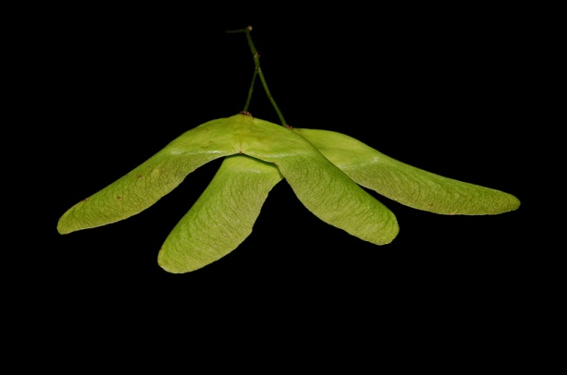
“The twirling seeds of maple trees spin like miniature helicopters as they fall to the ground. Because the seeds descend slowly as they swirl, they can be carried aloft by the wind and dispersed over great distances.”
“By swirling, maple seeds generate a tornado-like vortex that sits atop the front leading edge of the seeds as they spin slowly to the ground. This leading-edge vortex lowers the air pressure over the upper surface of the maple seed, effectively sucking the wing upward to oppose gravity, giving its boost.”
Source: AskNature.org

Hornbeam-
Carpinus
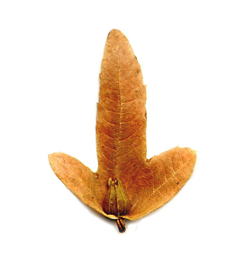
Just like the maple seed, this shape allows for rotating and is swept away by the wind as it falls in order to disperse its seeds. Leading edge vortices lower the air pressure over the upper surface of the seed and provide lift.

Elm Seed-
Ulmaceae
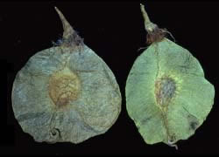
The seed is located at the center of an extremely thin outer pod. The thinness of the pod allows it to be light weight, and air pockets accumulate under the pod as it falls, slowing the decent and flutters, being carried away by the wind in order to disperse and plant somewhere else.
Whirling Nut-
Gyrocarpus
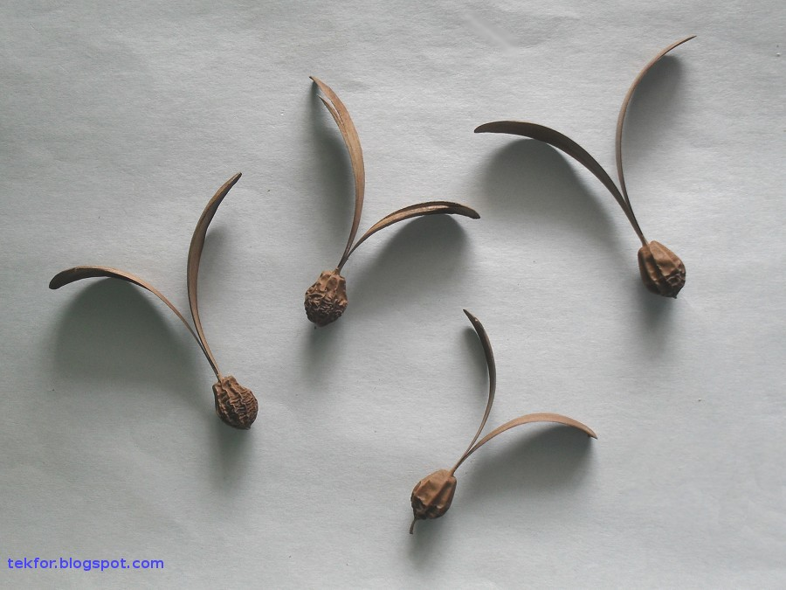
The whirling nut is the seed for the Gyrocarpus plant found in pantropical climates. As the seed falls from the plant the propeller-like appendages cause the seed pod to spin rapidly much like a helicopter, slowing its decent and allowing it to be carried away by the wind and settle to be planted somewhere else.

