NAME: |  |  |  |  | EMAIL:
LESSON 1: THE IMPORTANCE OF MENTAL AND EMOTIONAL HEALTH
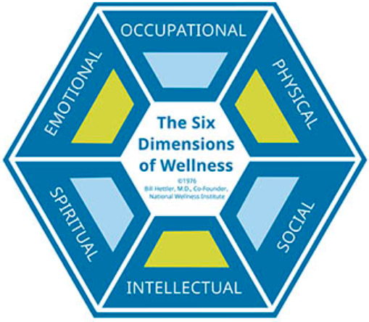 |  |  |  |  |  |  | Notes:  Physical Health –  Occupational Health –  Social Health –  Spiritual Health –  Mental (Intellectual) Health –  Emotional Health –
Pie Chart  Activity: |  |  |  |  |  | Most Influential and Why?
 |  |  |  |  |  | Least Influential and Why?
1. Mental (Intellectual) Health:

2. Emotional Health:

Positive MEH Behaviors  ____ Express Feelings  ____ MEH Activities  ____ Interpersonal Conflicts  ____ Manage Stress  ____ Self- & Impulse-Control  ____ Help For Oneself/Others  ____ Accept Differences  ____ Healthy Relationships |  |  |  | Explain Your #1:  Explain Your #8:
MEH Interview:
1. How do you expresses feelings?

2. What activities do you do to maintain MEH?

3. How do you prevent/manage interpersonal conflicts?

4. How do you manage stress and anxiety?

5. How do you control your emotions (e.g. anger, sadness):

6. How do you get help for MEH-related issues?

7. How do you show acceptance of others?

8. How do you establish/maintain healthy relationships?

Interviewee’s Signature:

Participation  Grade: ____ / 29 |  | Teacher Comments:
LESSON 2: IMPROVING MENTAL AND EMOTIONAL HEALTH
I want to change and take more responsibility for how I…

I want to do this because…

Concepts:  1.  2. |  |  | Skills:  1.  2. |  |  |  |  | Resources:  1.  2.
Unhealthy Option: |  |  | Healthier Option #1: |  |  |  |  | Healthier Option #2:
⇓ |  |  | ⇓ |  |  |  |  | ⇓
If you continue to do this…  Short-Term Effects:  1.  2.  Long-Term Effects:  1.  2. |  |  | If you continue to do this…  Short-Term Effects:  1.  2.  Long-Term Effects:  1.  2. |  |  |  |  | If you continue to do this…  Short-Term Effects:  1.  2.  Long-Term Effects:  1.  2.
SMART Goal: Over the next five days,

Measurable steps to the goal: | Starting and completion dates: |  |  |  | What do I need? |  |  |  | Did I achieve it? If not, what is my solution?
Step 1 Reflection: Did you make the healthier decision? How difficult was it and why?

Signature Of The Witness:

Project  Grade: ____ / 42 |  | Teacher Comments:
LESSON 3: INTERPERSONAL CONFLICTS
RMC Defusing Conflict Model
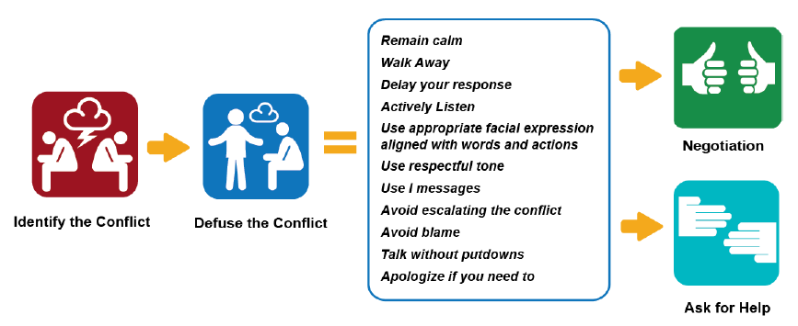
RMC Negotiation Model
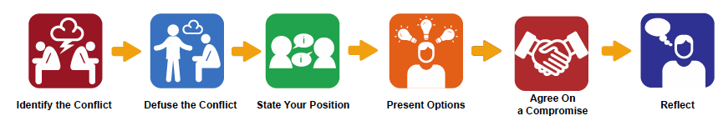
Six Tips for Resolving Conflict from Helpguide.org
1. Listening –
2. Making the Resolution the Priority –
3. Focusing on the Present –
4. Picking your Battles –
5. Forgiving –
6. Letting Go –
Best Strategy –

Questionable Strategy –

Role Play Checklist:
1) Decided on a realistic situation. ____
2) Decided on a person you are having a conflict with (i.e. family member, peer, or boyfriend/girlfriend). ____
3) Followed the Defusing Conflict/Negotiation Skills Models. ____
4) Used the at least two of the six tips² in your role play. ____
Best Strategy –

Questionable Strategy –

Participation  Grade: ____ / 14 |  | Teacher Comments:
LESSON 4: COPING WITH GRIEF AND STRESS
Barrier #1: |  |  | Barrier #2: |  |  |  |  | Barrier #3:
⇓ |  |  | ⇓ |  |  |  |  | ⇓
Possible Solution: |  |  | Possible Solution: |  |  |  |  | Possible Solution:
Notes Outline: Cope with Loss/Grief from Helpguide.org
Grief is a natural response to loss.
List three personally relevant situations that could cause grief.
1.
2.
3.
The Five Stages of Grief: Denial, anger, bargaining, depression, acceptance
Emotional Symptoms of Grief: Shock/disbelief, sadness, guilt, anger, and fear
Physical Symptoms of Grief: Fatigue, nausea, lower immunity, weight change, aches/pains, insomnia
Six Ways to Take Care of Yourself as You Grieve:
1.
2.
3.
4.
5.
6.
What should you do if grief doesn’t go away?

When should you seek professional help?

Managing Stress:
What Are Some Negative Effects of Stress?

Three Strategies For Managing Stress That I Could Use:
1.
2.
3.
Valid/Reliable Website(s):

What did you try and how well did it work?
Homework  Grade: ____ / 26 |  | Teacher Comments:
LESSON 5: ASKING FOR AND OFFERING ASSISTANCE
Final Goal Reflection:

Self-Injury:

Suicide:

Warning Signs From Mentalhealth.gov:
1.
2.
3.
4.
What To Look For From Mentalhealth.gov:
Anxiety Disorders:
Behavioral Disorders:
Eating Disorders:
Mental Health and Substance Abuse Disorders:
Mood Disorders:
Obsessive-Compulsive Disorder:
Personality Disorders:
Psychotic Disorders:
Suicidal Behavior:
Trauma and Stress-Related Disorders:
When Would You Seek Help For Yourself About A MEH Problem?

When Would You Seek Help For Someone Else About A MEH Problem?

Participation  Grade: ____ / 24 |  | Teacher Comments:

